**NAAN MUDHALVAN**

**INTERNET OF THINGS- IBM**

**PROJECT – ENVIRONMENTAL MONITORING USING IOT**

**PHASE 2**

**TEAM MEMBERS**

1) KAILAASH RM

2) HEMANTH RV

3) DHIVYA PRADEEP

4) THAARINI DEVI S

5) SHANTHINI DEVI P

**B.E BIOMEDICAL ENGINEERING**

**COLLEGE OF ENGINEERING GUINDY**

# ENVIRONMENTAL MONITOING USING IOT

## PHASE 2

INNOVATION:

Our project mainly aims on detecting the critical conditions of the surrounding environment in a public park, using low cost and high quality sensors, process the data from the sensor and by using IOT technology, the monitored conditions and the sensed parameters are displayed to the visitors using mobile or web based application.

This being the main objective of our project, the innovations that are added as a crown to our project would be,

* Comparing the sensed parameters with their normal values and creating a alert system when conditions get worse
* Apart from measuring the temperature and humidity, using IOT we record the number of visitors to the park every day.
* Sensors would include temperature (Thermistor), capacitive based humidity sensor and also water quality monitoring sensors (if there is water in the park).
* Feedback and suggestions from the users.
* Smart Waste Management using sensor fixed smart bins.

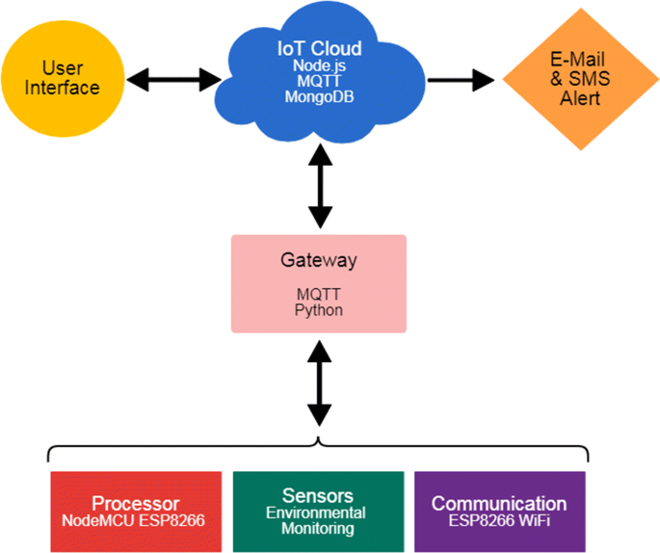

**Alert System for Abnormal Conditions:**

This is a crucial feature as it helps in proactive environmental management. When the sensed parameters deviate from their normal values, an alert system can be triggered.

The thresholds are set for various environmental factors like temperature, humidity, and water quality. When these thresholds are crossed, the system can send alerts to park authorities or even visitors to take appropriate action.

**Visitor Counting:**

* + Monitoring the number of visitors is not only useful for park management but can also enhance the visitor experience.
  + Utilizing IoT technology, you can deploy visitor counting sensors at key entry points to the park. These sensors can count the number of people entering and leaving the park.
  + This data can be displayed on the mobile or web application, allowing visitors to check the current park occupancy before their visit.

**Data Visualization for Visitors:**

* The mobile or web-based application can provide real-time and historical data on environmental conditions in the park and it is user friendly.
* This can include temperature, humidity, visitor count, and water quality data in an easily understandable format like graphs or charts.

**Energy Efficiency:**

* Use of low-power sensors and energy-efficient IoT devices to minimize the environmental impact of your monitoring system.

**Smart Waste Management:**

Install sensors in the waste bins placed strategically throughout the park. These sensors can detect the fill level of the bins. This information can be relayed to park authorities for timely waste collection, improving park cleanliness.

**Feedback:**

* The mobile app will be designed in such a way that, the visitors or the users can add on their feedbacks and suggestions in order to improve the quality of the environment as well as the app.